CAN COMMUNICATION USING ESP32 AND MCP2515

Connections
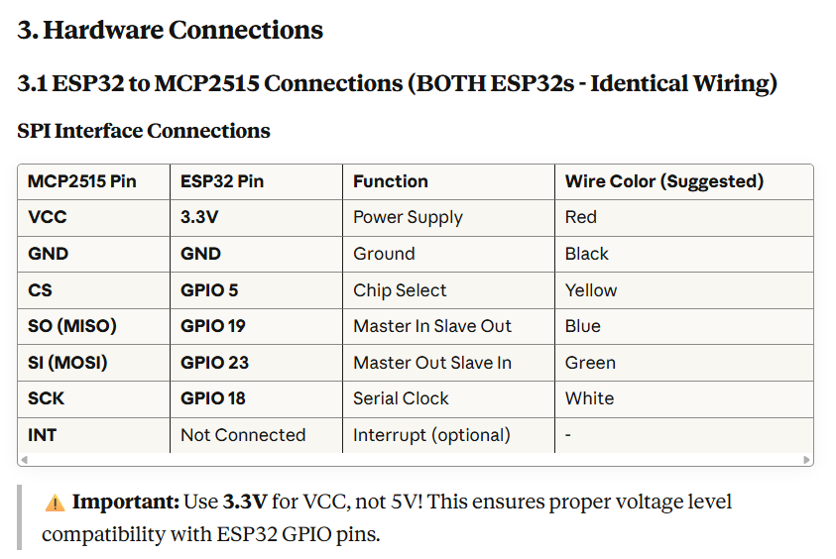
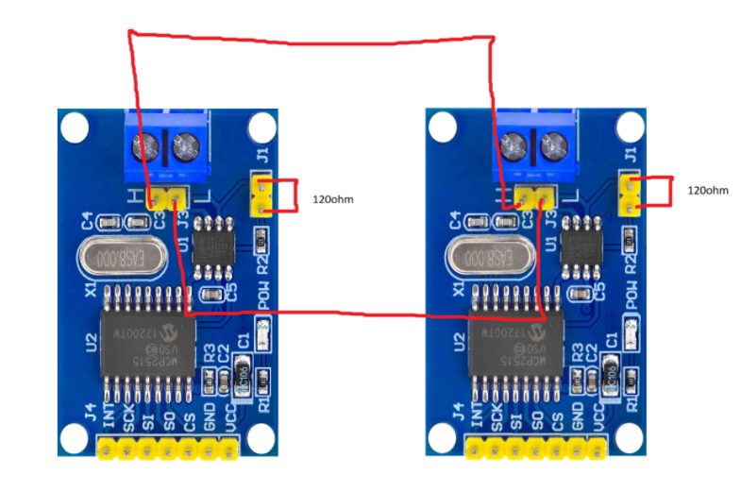
Code
Tx:
//==================================================================================//
// BMS TRANSMITTER - ESP32 #1
// Sends dummy battery management system parameters
//==================================================================================//
#include <SPI.h>
#include <mcp2515.h>

MCP2515 mcp2515(5);

#define BMS_DATA_ID 0x100 // CAN ID for BMS data
#define ACK_ID 0x101 // CAN ID for acknowledgment

// BMS Parameters (dummy values that will change)
float voltage = 12.50; // Voltage in V
float current = 2.50; // Current in A
int charge = 85; // Charge percentage
float temperature = 25.0; // Temperature in °C
int cycles = 240; // Charge cycles
float power = 31.25; // Power in W
String status = "Excellent"; // Battery status

unsigned long lastSend = 0;
unsigned long messageCount = 0;

//==================================================================================//
void setup() {
Serial.begin(9600); // Changed to 9600 to match your screenshot
delay(2000);

Serial.println("\n===========================================");
Serial.println(" BMS TRANSMITTER");
Serial.println("===========================================");

SPI.begin();
mcp2515.reset();
delay(100);

// Auto-detect crystal
MCP2515::ERROR result = mcp2515.setBitrate(CAN_500KBPS, MCP_8MHZ);
if (result != MCP2515::ERROR_OK) {
mcp2515.setBitrate(CAN_500KBPS, MCP_16MHZ);
}

mcp2515.setNormalMode();

Serial.println("✓ CAN initialized");
Serial.println("✓ Sending BMS data...");
Serial.println("===========================================\n");
delay(1000);
}

//==================================================================================//
void loop() {
if (millis() - lastSend >= 2000) {
updateBMSData();
sendBMSData();
lastSend = millis();
}
}

//==================================================================================//
void updateBMSData() {
// Simulate changing battery parameters
voltage += random(-10, 10) / 100.0;
if (voltage < 11.0) voltage = 11.0;
if (voltage > 13.5) voltage = 13.5;

current += random(-20, 20) / 100.0;
if (current < 0.5) current = 0.5;
if (current > 5.0) current = 5.0;

charge += random(-2, 2);
if (charge < 0) charge = 0;
if (charge > 100) charge = 100;

temperature += random(-5, 5) / 10.0;
if (temperature < 20.0) temperature = 20.0;
if (temperature > 35.0) temperature = 35.0;

cycles += random(0, 2);
if (cycles > 500) cycles = 240;

power = voltage * current;

// Update status based on charge
if (charge > 80) status = "Excellent";
else if (charge > 50) status = "Good";
else if (charge > 20) status = "Low";
else status = "Critical";
}

//==================================================================================//
void sendBMSData() {
messageCount++;

// Pack BMS data into CAN frames
// We'll send 4 separate CAN messages to fit all data

// Frame 1: Voltage, Current (8 bytes)
struct can_frame frame1;
frame1.can_id = BMS_DATA_ID;
frame1.can_dlc = 8;

int voltageInt = (int)(voltage * 100); // 12.70V -> 1270
int currentInt = (int)(current * 100); // 2.50A -> 250

frame1.data[0] = (voltageInt >> 8) & 0xFF;
frame1.data[1] = voltageInt & 0xFF;
frame1.data[2] = (currentInt >> 8) & 0xFF;
frame1.data[3] = currentInt & 0xFF;
frame1.data[4] = charge;
frame1.data[5] = (int)(temperature * 10) & 0xFF;
frame1.data[6] = (cycles >> 8) & 0xFF;
frame1.data[7] = cycles & 0xFF;

Serial.print("Transmitting: BAT:");
Serial.print(voltage, 2);
Serial.print(",");
Serial.print(current, 2);
Serial.print(",");
Serial.print(charge);
Serial.print(",");
Serial.print(temperature, 1);
Serial.print(",");
Serial.print(cycles);

if (mcp2515.sendMessage(&frame1) == MCP2515::ERROR_OK) {
Serial.println(" → SENT ✓");
} else {
Serial.println(" → FAILED ✗");
}

delay(50);
}

Rx:
//==================================================================================//
// BMS RECEIVER - ESP32 #2
// Receives and displays battery management system parameters
//==================================================================================//
#include <SPI.h>
#include <mcp2515.h>

MCP2515 mcp2515(5);

#define BMS_DATA_ID 0x100 // CAN ID for BMS data
#define ACK_ID 0x101 // CAN ID for acknowledgment

// BMS Parameters
float voltage = 0.0;
float current = 0.0;
int charge = 0;
float temperature = 0.0;
int cycles = 0;
float power = 0.0;
String status = "Unknown";

unsigned long lastReceived = 0;
unsigned long totalReceived = 0;

//==================================================================================//
void setup() {
Serial.begin(9600); // Changed to 9600 to match your screenshot
delay(2000);

Serial.println("\n===========================================");
Serial.println(" BMS RECEIVER");
Serial.println("===========================================");

SPI.begin();
mcp2515.reset();
delay(100);

// Auto-detect crystal
MCP2515::ERROR result = mcp2515.setBitrate(CAN_500KBPS, MCP_8MHZ);
if (result != MCP2515::ERROR_OK) {
mcp2515.setBitrate(CAN_500KBPS, MCP_16MHZ);
}

mcp2515.setNormalMode();

Serial.println("✓ CAN initialized");
Serial.println("✓ Waiting for BMS data...");
Serial.println("===========================================\n");
delay(1000);
}

//==================================================================================//
void loop() {
struct can_frame rxMsg;

if (mcp2515.readMessage(&rxMsg) == MCP2515::ERROR_OK) {
if (rxMsg.can_id == BMS_DATA_ID) {
totalReceived++;

// Decode BMS data
int voltageInt = (rxMsg.data[0] << 8) | rxMsg.data[1];
voltage = voltageInt / 100.0;

int currentInt = (rxMsg.data[2] << 8) | rxMsg.data[3];
current = currentInt / 100.0;

charge = rxMsg.data[4];

temperature = rxMsg.data[5] / 10.0;

cycles = (rxMsg.data[6] << 8) | rxMsg.data[7];

power = voltage * current;

// Determine status based on charge
if (charge > 80) status = "Excellent";
else if (charge > 50) status = "Good";
else if (charge > 20) status = "Low";
else status = "Critical";

// Display battery status in the exact format you want
displayBatteryStatus();

lastReceived = millis();
}
}

// Show "waiting" message if no data received for 5 seconds
if (millis() - lastReceived > 5000 && totalReceived > 0) {
Serial.println("⚠ No data received for 5 seconds...");
lastReceived = millis();
}

delay(10);
}

//==================================================================================//
void displayBatteryStatus() {
Serial.println("=== BATTERY STATUS ===");
Serial.print("Voltage: ");
Serial.print(voltage, 2);
Serial.println(" V");

Serial.print("Current: ");
Serial.print(current, 2);
Serial.println(" A");

Serial.print("Charge: ");
Serial.print(charge);
Serial.println(" %");

Serial.print("Temp: ");
Serial.print(temperature, 1);
Serial.println(" °C");

Serial.print("Cycles: ");
Serial.println(cycles);

Serial.print("Power: ");
Serial.print(power, 2);
Serial.println(" W");

Serial.print("Status: ");
Serial.println(status);

Serial.println("======================\n");
}

Output:
